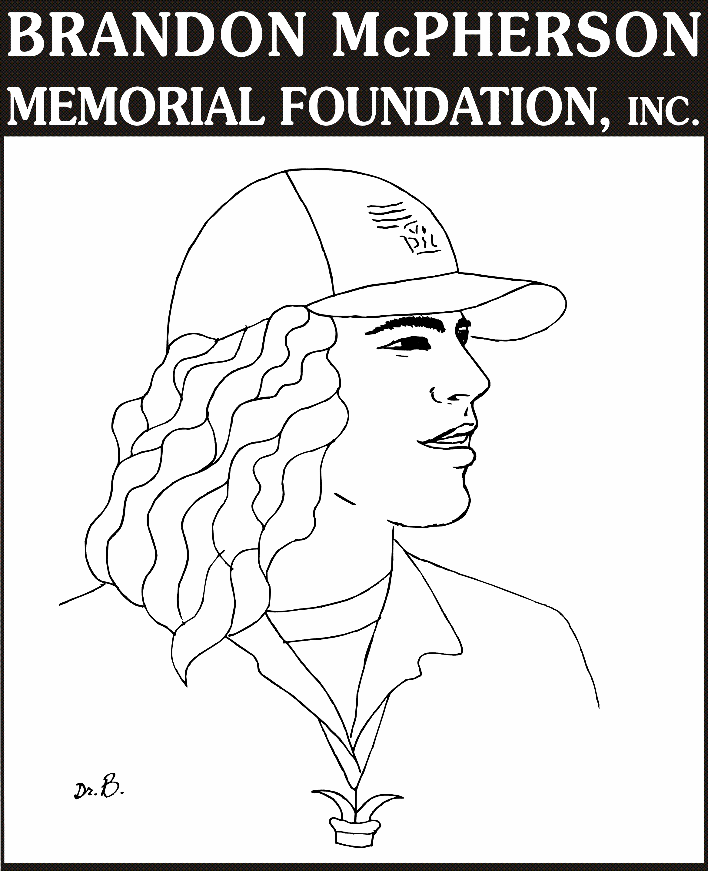

Brandon McPherson Memorial Foundation, Inc.
Excellence in Education Grant Application 2014

“Creating Extraordinary Opportunities”
In keeping with the mission of the BMMF, Inc., Excellence in Education grants are awarded in honor of the extraordinary life and character of Brandon McPherson. These grants are awarded to educators who seek to implement innovative, unique learning experiences in their classrooms and who exhibit the leadership qualities of Brandon McPherson.

General Information:
- Who is eligible? Certified K-12 classroom teachers and library media specialists in the Northland school districts of Park Hill, Liberty, Kearney, North Kansas City, Platte County, Smithville and Northland Catholic Schools.

- Grant applications may be submitted individually or by a group of staff members. Previous applicants and previous grant winners MAY apply again to receive funding up to $500.

- Requests for funding must be specifically applicable to student learning and may include instructional items (such as books, teaching or instructional aids, videos/DVDs, etc.), classroom materials (such as technology upgrades/equipment, office supplies, etc.), or special learning opportunities (field trips, guest authors, speakers, educator professional development or student workshops, science labs, etc.) that will practically benefit your classroom or school as a whole.

- Grants will be awarded for amounts up to $500.00.

- All completed grant applications will be reviewed and rated by the BMMF, Inc. Excellence in Education Grants committee. Identifying information (applicant names, schools, contact information) will be removed during the judging process.

- Grant winners will be announced November 30, 2014 via the BMMF, Inc. website: www.bluebullshark.com.

Completed application materials must be postmarked on or before November 15th, 2014 to be considered for funding for the 2014-2015 school year. The foundation’s president is available to answer basic questions related to this application; for information, please contact Brit McPherson at contactus@bluebullshark.com or (816) 769-8424.

Submit 1 paper copy with cover page of completed application to:
Brandon McPherson Memorial Foundation, Inc.
c/o Excellence in Education Grants Committee
7616 NW Eastside Drive
Weatherby Lake, MO 64152

Brandon McPherson Memorial Foundation, Inc.
Excellence in Education Grant Application
Cover Page

DATE:
APPLICANT NAME(S):
GRADE LEVEL/SUBJECT(s):

SCHOOL NAME/
SCHOOL DISTRICT:

Contact Information: | Home phone _______________________________  School phone _______________________________  E-Mail _____________________________________
PROJECT TITLE:
Do you give the BMMF, Inc. permission to publish your name and winning project title on its website and in press releases? | Signature(s) of applicant(s)
FUNDING AMOUNT REQUESTED:
Brandon McPherson Memorial Foundation, Inc.
Excellence in Education Grant Application 2014

PROJECT TITLE:
AMOUNT REQUESTED:
NAME OF ITEM(S) REQUESTED/  PROJECTED BUDGET  (Please itemize all expenses requested.) | Item Estimated Cost Vendor
BRIEF
PROJECT DESCRIPTION:

WHAT NEED OR
OPPORTUNITY IS
ADDRESSED BY THIS
PROJECT?

HOW WILL THIS ITEM BENEFIT STUDENTS?

Please describe specifically how this item, project, or learning opportunity will be utilized in your classroom or the school.

WILL YOU BE ABLE TO REUSE THIS ITEM IN YEARS TO COME?

CAN THIS PROJECT BE REPLICATED OR BECOME SELF-SUSTAINING?

WILL YOU BE ABLE TO SHARE THIS ITEM OR LEARNING OPPORTUNITY WITH OTHER STAFF MEMBERS?

ARE YOU A PREVIOUS RECIPIENT OF A BRANDON McPHERSON MEMORIAL FOUNDATION, INC. EXCELLENCE IN EDUCATION GRANT?

